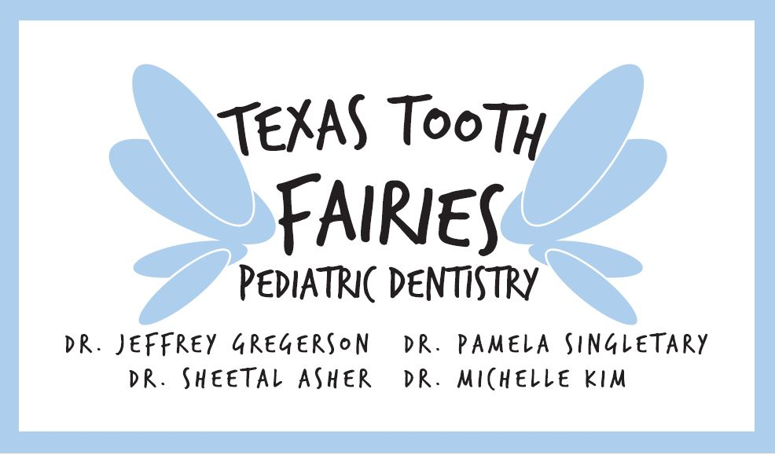

Behavior Management Techniques

It’s our intent that here in our office we strive for providing high quality care at all times for each individual child. With that being said we understand that sometimes it may be made very difficult or even impossible; due of the lack of cooperation of some children. We find that the following behaviors can interfere with the proper provision of quality dental care: hyperactivity, resistive movements, refusing to open the mouth or keep it open long enough to perform the necessary dental treatment and even aggressive or physical resistance to treatment, such as kicking, screaming and grabbing the dentist’s hands or the sharp dental instruments. All efforts will be made to obtain the cooperation of the child by the use of warmth, friendliness, persuasion, humor, charm, gentleness, kindness and understanding. There are several behavior management techniques that are used by pediatric dentists to gain the cooperation of children to eliminate disruptive behavior or prevent patients from causing injury to themselves due to uncontrollable movements.
The more frequently used pediatric dentistry behavior management techniques are as follows:
- Tell-show-do: The dentist or assistant explains to the child what is to be done using simple terminology and repetition and then shows the child what is to be done by demonstration with instruments on a model or the child’s or dentist’s finger. Then the procedure is performed on the child’s mouth as described. Praise is used to reinforce cooperative behavior.
- Positive reinforcement. This technique rewards the child who displays any behavior which is desirable. Rewards include compliments, praise, a pat on the back, a hug or prize.
- Voice Control: The attention of a disruptive child is gained by changing the tone or increasing the volume of the dentist’s voice. Content of the conversation is less important that the abrupt or sudden nature of the command.
- Mouth Props: A rubber or plastic device is placed in the child’s mouth to prevent closing when a child refuses or has difficulty maintaining an open mouth. The item is referred to as a “pillow” and simply aids the child in keeping his/her mouth open.
- Head Control: The dentist stabilizes the child’s head between the dentist’s arm and body. The dental assistant may often assist in stabilizing the child’s head and preventing the child from flaring their head while the dentist performs the restorative procedure which is deemed necessary.
- Physical Restraint by the Assistant: The assistant restrains the child from movement by holding the child’s hands, stabilizing the head and/or controlling leg movements. The doctor treating your child may ask you to assist in controlling them as necessary.
- Papoose Boards & Pedi-Wraps: These are restraining devices for limiting the disruptive child’s movements to prevent injury and to enable the dentist to provide the necessary treatment. The child is wrapped in this device and placed in a reclined dental chair. We refer to these devices as a “blanket” or “tiny surf-board” so as not to frighten the child. This device will not be used without your being further informed and obtaining your specific approval and consent for such procedures.
- Sedation: Sometimes drugs are used to relax a child who does not respond to other behavior management techniques or who is unable to comprehend or cooperate for the dental procedures. These drugs may be administered orally. The child does not become unconscious. Your child will not be sedated without you being further informed and obtaining your specific consent for such procedure.
- General anesthesia: The dentist performs the dental treatment with the child anesthetized in the hospital operating room. Your child will not be given anesthesia without your being further informed and obtaining your specific consent for such procedure.

Please know that we are looking out for the best interests when preforming the above techniques, we strive to make sure that your child, our staff and Doctors are safe and feel comfortable while being in the office. If you have any questions or concerns about the above statements, please feel free to bring it to our attention.

